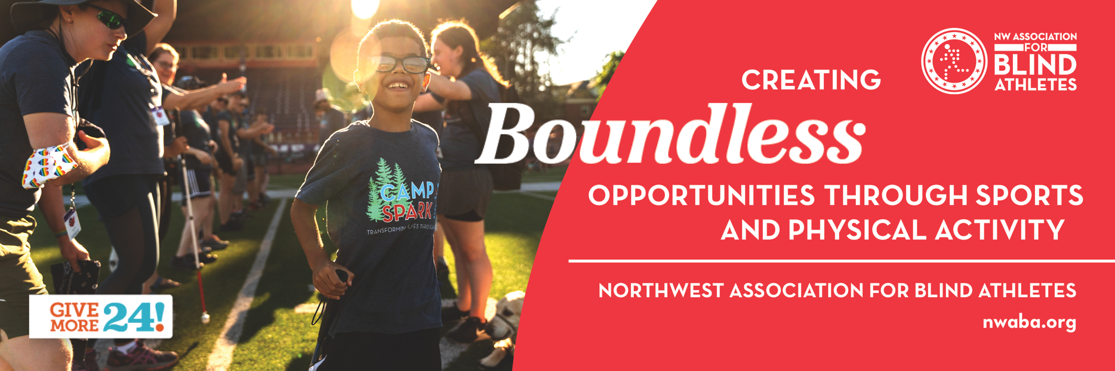
Fundraising Toolkit

Thank you for supporting in Give More 24!! On September 23rd, 2021, our goal is to raise $51,000 to provide boundless opportunities through sports and physical activity to those who are blind and visually impaired in Southwest Washington. Peer-to-Peer fundraising is a great tool to help engage as many of our family, friends, and colleagues as possible during the whole giving day. With each donation being matched thanks to our matching donors, we are confident in reaching our goal!

In this kit, you’ll find sample emails, social media posts, directions on how to set-up your peer-to-peer fundraising campaign and more to help you spread the word, and reach your own fundraising goal for Give More 24!. If you need assistance, please contact Alyssa Baldwin, Marketing & Communications Manager, at abaldwin@nwaba.org or at 360-768-5647.

Peer-to-Peer Fundraising Page Set-up

If you would like to set-up your own fundraising page through our Just Giving peer-to-peer fundraising portal, please follow the directions outlined below or visit the Give More 24! page at https://www.givemore24.org/organizations/nwaba

This year, whoever raises the most on their fundraising page will win an NWABA t-shirt!

How do I become a Peer-to-Peer Fundraiser?
If you weren't invited to fundraise for an organization, you can still sign up! Just search for your NWABA, view our profile, and click the Fundraise button.

What link do I share?
You'll want to share the link created for your fundraising page found in your Fundraising Dashboard.
You can also share NWABA’s main campaign link, and your supporters will still be able to donate to your specific page!

How do I get the word out?
To get the word out about Give More 24!, you'll want to communicate with your contacts through email messages, social media posts, and word of mouth. Check out some of the sample content attached for ideas of what to post and when!

If you need assistance, please contact Alyssa Baldwin, Marketing & Communications Manager, at abaldwin@nwaba.org or at 360-768-5647.

Email Templates

Kick off your fundraising efforts by sending an email to each of your prospective donors.

General or First email
Dear [NAME],

I hope this email finds you well.

I’m writing to tell you about a fundraiser I’m holding to benefit Northwest Association for Blind Athletes (NWABA) during Give More 24!, which is an all-day giving day supporting Southwest Washington, September, 23rd, 2021. This campaign is one of NWABA’s most impactful campaigns of the year that helps fuel life-changing programs and services for children, youth, and adults with visual impairments in this area.

This year, your gift will be matched! $25=$50, $50=$100, $100=$200!

To help reach their goal of $51,000, I’ve committed to fundraising [$$]—but I need your help! Please follow the link below and learn more about NWABA. Thanks for your consideration and generosity.

All the Best,
[INSERT NAME]
[INSERT LINK TO Fundraising Page]

Progress Report email

Dear [NAME],

Happy Thursday! I wanted to update you on my personal goal to raise [$$$] for Northwest Association for Blind Athletes, today, for Give More 24!.

I’ve raised [$$$] so far, but I still need your help! Please visit the link below to learn more about NWABA and make a tax-deductible donation.

Fundraising Page

I hope you’ll also share the details of my fundraising page with anyone in your network who would be interested in supporting. Remember, your donation is doubled thanks to a matching donation!

A huge thank you to all the people who have supported me so far; I couldn’t do this without you!

All the Best,

[INSERT NAME]

Thank You email

Dear [NAME],

Thank you so much for supporting my fundraiser by giving to Northwest Association for Blind Athletes (NWABA) for Give More 24!. Your donation is making an impactful difference in the lives of our athlete participants who are visually impaired.

NWABA changes lives by introducing individuals with visual impairments to sports and a diverse range of physical activity. Many of our athletes and their families have never experienced the adaptive sports our programs provide, and when they get the opportunity to do so, they have more self-confidence and are opened up to the possibility that they really can pursue their dreams in both sports and life. Our athletes leave behind sedentary, isolated lives and they gain skills, confidence, and joy.

All the Best,

[INSERT NAME]
Fundraising Page

Social Media

Customize the posts below to let everyone in your social network know how they can support you.
Tag NWABA in Your Social posts:
Facebook: @NorthwestAssociationforBlindAthletes
Instagram: @nwblindathletes
Twitter: @NWABA
LinkedIn: @NorthwestAssociationforBlindAthletes
Hashtags: #igavetonwaba #givemore24 #nwblindathletes #nwaba

Short-form Social Media Posts
Posts are 280 characters or less; perfect for all social channels including Twitter.

Life-changing programs for individuals with visual impairments in SW Washington. That’s why I’m raising funds for Northwest Association for Blind Athletes. Join me in supporting NWABA in Give More 24! today! https://www.givemore24.org/organizations/nwaba

OR

I believe that individuals who are visually impaired need boundless opportunities to foster confidence. That’s why I’m committed to raising [$$$] for Northwest Association for Blind Athletes. Join me in supporting this great organization during this giving day! www.nwaba.org/gm24

Long-form Social Media Posts
Posts are 280+ characters, and can be shared on Facebook, Instagram, or LinkedIn.

September 23rd, 2021, is Give More 24!, an all-day giving day that supports individuals in SW Washington. I am committed to raising [$$$] for Northwest Association for Blind Athletes because I believe that visually impaired individuals need boundless opportunities to gain confidence and foster independence.

Research shows that most of the nation’s blind or visually impaired school-age children have never participated in sports, physical activities, or a proper physical education program.

And, approximately 60% of adults who are blind or visually impaired are unemployed or underemployed. Immobile children and teens grow to become sedentary adults, lacking self-confidence, independence, muscular and cardiovascular health, and a true sense of community.

“Our son has heard time after time that he CAN do anything and everything he sets his mind to. However, riding a bike, what you and I might see as a simple recreational activity, was unheard of for our boy. Thanks to NWABA, our son, Octavio, was able to experience what it meant to ride a bike for the first time.”
- Athlete Octavio’s Mom.

Northwest Association for Blind Athletes (NWABA) programs and services give children, youth, and adults the opportunity to participate in sports and physical activities both in person and virtually. Once introduced to NWABA’s programs, individuals who are blind and visually impaired build self-esteem, confidence, physical fitness, and success in all other areas of life.

Join me in supporting this great organization and help them reach their goal of $51,000. Your donation will be matched! https://www.givemore24.org/organizations/nwaba

How to Turn in Donations

Online Donations
Any donation made through your online fundraising page will receive an automatic receipt through our donation platform. There’s no need to keep track of these donations.

Offline Donations (Cash or Checks)
To receive credit on your fundraising event page, cash and check donations must be
mailed to our office:
Attn: Mckenzie Barton
Northwest Association for Blind Athletes
PO Box 61489
Vancouver, WA 98666

Check Donations
• Checks should be made out to “Northwest Association for Blind Athletes” or “NWABA”
• Write your name in the memo line so we know to credit your fundraising page
• NWABA will send a thank-you note/receipt to donors using the address on the check

Cash Donations
If cash donors would like a receipt, please provide the following donor information*:
• Name
• Address
• City, State, Zip
• Phone
• Email
• Total Donation

*Your donor will receive a thank-you note/receipt from NWABA and a staff member will update your fundraising page with the donation and your new total. Please allow five business days from receipt for the update.

Matching Gifts
You may have friends and family who work at companies that provide charitable matching donations—this will help you reach your goal by doubling your incoming
donations!

If your contacts are interested in this type of donation, you can get more information
by visiting www.nwaba.org/donate, or contact Alyssa Baldwin, our Marketing & Communications Manager, at abaldwin@nwaba.org for assistance.

See last page for imagery.

Social Posts:
Email:
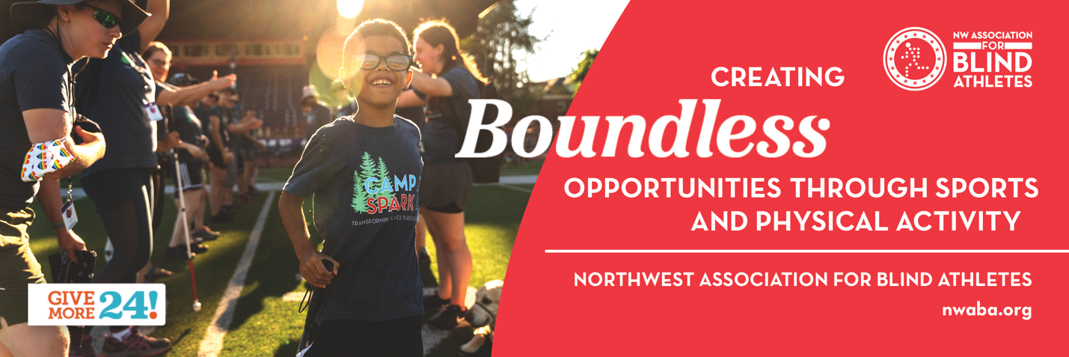
FB/IG/LinkedIn
